Extreme Sea Levels and Flood Events in a Coastal Town: Community Participatory Exercise and Inundation Analysis
Matthew P. Wadey¹., Samantha N. Cope^{2, 3}., Robert J. Nicholls⁴., Karen McHugh⁵., Gareth Grewcock⁶., Travis Mason^{2,3}.
- Ocean and Earth Sciences, National Oceanography Centre, European Way, University of Southampton, UK, m.p.wadey@soton.ac.uk; m.p.wadey@soton.ac.uk
- Channel Coastal Observatory, National Oceanography Centre, European Way, University of Southampton, UK
- New Forest District Council, Appletree Court, Beaulieu Road, Lyndhurst, Hampshire SO43 7PA
- Solent Forum, Hampshire County Council, The Castle, Winchester. SO23 8UE, UK
- Faculty of Engineering and the Environment, University of Southampton, UK
- Senergy Energy Services, 27 Gay Street, Bath, BA1 2PD, UK

To submit to Environmental Modelling & Software
Abstract
Extreme sea level events are a widespread threat to coastal communities, whilst sea-level rise (SLR) is increasing the probability of extreme sea level events caused by high tides and storm surges. This paper describes an analysis of flooding in a small coastal town (Yarmouth, Isle of Wight) to inform local stakeholders about flood risk and flood risk management. It develops an existing numerical modelling framework as the underlying tool. It has two parts: (1) a participatory visualisation exercise of three selected scenarios that were driven by local concerns following a significant recent coastal flood event; and (2) an extended event analysis to place the visualised scenarios into a broader perspective with floods of previous decades and the extreme 2013-2014 storm season. This paper discusses how methods to predict and understand flooding via scenarios and numerical inundation simulations can engage the interest of a coastal community. Technical and practical lessons and uncertainties are highlighted. Outcomes include the successful integration of detailed datasets and software, as well as dissemination and positive feedback to the project which contributed to an ‘Adaptation Plan’ for future floods. Thoughts on further work and next steps are included.
Key words: coastal flooding, extreme sea level, storm surge, sea level rise, 2D modelling, climate adaptation

- Introduction
The low elevation coastal zone (LECZ) is vulnerable to the effects of extreme sea level events and climate change (e.g. McGranahan et al., 2007; Lichter et al, 2010). Global estimates suggest in excess of 145 million people live within 1 m of high tide level, with a further 100 million within 5 m of high tide (Anthoff et al., 2006), and without adaptation 0.2-4.6% of global population Is expected to be flooded annuanllly in 2100 (under 0.25-1.23 m global mean sea level rise) (Hinkel et al., 2014). Coastal flood risk management has seen significant progress since the North Sea floods of 1953 (307 killed in the UK, 1836 in the Netherlands and 17 in Belgium) (Steers, 1953; McRobie et al., 2005; Baxter, 2005) and the 1962 Elbe floods (300 people killed in Germany) (Bütow, 1963). Consequently, large coastal floods are now considered rarer events, due to improved risk management (i.e. defences, monitoring, forecasting and warning, building methods, emergency management, etc.). However, recent reminders of the threat of storm surge events include floods on the US Gulf coast in August 2005, French Atlantic coast February 2010 and US east coast October 2012. In the UK, which contains this paper’s case study, significant events have occurred since 1953 (e.g. Fleetwood, England, 11 November 1977; Bristol Channel/Somerset, 13 December 1981; Towyn, Wales 26 February 1990; UK storm season November 2013-February 2014). However, defences and warnings have mostly been effective, greatly reducing the consequences of these events.
Sea level rise (SLR) and urbanisation are increasing the exposure and risk of flooding in many regions (Evans et al., 2004; Haigh et al., 2010; Haigh et al., 2011; Hallegatte et al., 2013). Low lying shorelines, especially those without flood defence systems, are susceptible to changes in coastal flooding and face imminent decisions and changes to management practices (Wadey et al., 2012). In places exposed to coastal flooding, one way to improve management of this hazard is increasing emphasis on community participation, consultation, and provision of information (Jude et al., 2006). Landscape visualisation has been noted to convey strong messages quickly, condensing complex information, engaging people in issues of environmental change, and motivating personal action (Nicholson-Cole, 2005; Sheppard, 2005; Sheppard, 2012). Emerging powerful visualisation tools, numerical flood models and high resolution data sets provide opportunities to promote society to respond to virtual, as well as real, flood events. However, there are few publications which describe the deployment and dissemination of these techniques. The aims of this paper are to describe and evaluate coastal flooding via a scenario-based modelling at the scale of a small UK coastal town (the case study is Yarmouth, Isle of Wight, UK). The work has two main objectives:
- A participatory visualisation exercise (PVE): describe the production of detailed visualisations of a coastal flooding using a small number of scenarios (present day extreme sea levels and with SLR) as part of a community participation project;
- An extended event analysis (EEA): assess coastal flood events across a wider range of simulations and background data reflecting the experience of the stormy winter of 2013/2014 which caused three coastal floods.
Examining data visually in the flexible, interactive environment facilitated by the PVE can allow modellers and stakeholders to identify patterns, outliers and unexpected or abnormal features, beneficial to further conceptual frameworks and quantitative analysis methods (e.g. Billen et al., 2008). The EEA provides a wider set of results to set observations and scenarios into a wider context. Hence, these two approaches are complementary and reinforcing as discussed in the paper. The structure of this paper is as follows: the project and case study area are described (Section 2) followed by an overview of the data and methods (Section 3). Section 4 describes assesses the outcomes of the PVE and EEA, including an overview of the community engagement and project management, and the results for multiple flood simulations; followed by discussion of the approaches, results and implications/lessons for future work. (Section 5) and Conclusions (Section 6).

- Background to the project and the Yarmouth Case Study
2.1 Description of the case study
The case study is within the Solent, a body of water between Great Britain and the Isle of Wight (Figure 1). Present-day coastal flooding in the Solent region is characterised by almost 100 discrete floodplains, containing approximately 25,000 properties on land beneath a 1 in 200 annual probability sea level (Wadey et al., 2012). The Solent’s coastal zone contains densely populated and industrialised areas, and sites of environmental/ecological importance. Many communities have developed close to the water, including areas of reclaimed land, hard and natural defences which all have varying roles in the management of erosion and localised flooding. A review of media reports of floods and sea level history by Ruocco et al (2011) suggests that the region has experienced regular coastal flooding over the 20th century, often resulting in property damage, but with no known loss of life. There is anecdotal evidence that more severe events occurred in the 19th and early 20th centuries (West, 2010; Lamb, 1991). Yarmouth is a small port and market town which supports the Solent’s vibrant ferry and yachting trade and is one of the earliest settlements on the Isle of Wight. The present population is less than 800 (2001 Census). The case study area (refer to Figure 1) includes the urbanised town centre (east of the Swing Bridge) and a more rural area (west of the Swing Bridge). Like many settlements in the region, the standard of protection for flood defence is mixed (Wadey et al., 2013). Hard structures lie on the open coast, including a rock breakwater which provides shelter from waves in the harbour; whilst the rear of the town centre area is low lying and storm tides have previously flowed over the harbour wall. The west side comprises grassed embankments. There is flood risk from the sea along the northern edge of the town, and a combination of sea and fluvial risk from the estuary to the south and west (Entec, 2007). Yarmouth is sheltered from large waves due to its north facing orientation, and like much of the Solent is also protected from south-westerly waves by the managed shingle barrier known as Hurst Spit (Bradbury and Kidd, 1998).
Notable coastal flood events to affect Yarmouth were during 14-17 December 1989, 10 March 2008 and a number of incidences in the winter of 2013/2014 (Table 1). As seen in Figure 1, the land low enough to be affected by extreme sea levels extends several hundred metres inland, either side of the Swing Bridge. The Yar floodplains that bisect the east and west sides of the Island are more expansive and tidal inflows are now prevented by sluice gates which protect freshwater marshes and habitats. Lamb (1991) describes floods from a south-westerly storm during 9-11 November 1931 which covered the flood plain between Yarmouth and Freshwater Bay (a town approx. 5 km south of Yarmouth on the south coast) cutting off the area to the west. Table 1 also lists four coastal floods (1959-1981) associated with extreme sea levels in the Solent (from Ruocco et al, 2009).
Table 1. Flood events and sea level observations at Yarmouth. Available sea level observations at Lymington are also noted (see Figure 1) (estimations & tide gauge readings) (tide gauge source: channelcoast.org unless stated otherwise) (NRA, 1990). (EA, 2010)
Date | Sea level (SL) events (datum: mODN) |  |  |  |  |  | Flooding
 | Yarmouth |  |  | Lymington |  |  | Yarmouth | Wider perspective
 | SL | PT | Sk | SL | PT | Sk
19 October 1959 | N/A | N/A | N/A | N/A | N/A | N/A | Seawater swept over Bridge Road to a depth of several inches form waves 'pounding over the wall' (‘Daily Echo’). | Flooding reported in Lymington.
21 December 1968 | N/A | N/A | N/A | N/A | N/A | N/A | River Yar lapped over the road at High tide causing flooding over long stretch of road (‘The News’)
18 January 1969 | N/A | N/A | N/A | N/A | N/A | N/A | The Kings Head: serious flooding in saloon bar, carpets had to be taken up and bar closed to customers (‘Daily Echo’). | Several Isle of Wight seafront towns reportedly suffered “their worst flooding for several years caused by a combination of high tides, winds and heavy rain”.
14 December 1981 | N/A | N/A | N/A | N/A | N/A | N/A | Yarmouth noted as flooded (‘Daily Echo’) but details not available. | Floods reported in Cowes, Southampton and Portsmouth; “worst flooding in living memory” to the four-mile stretch of [Isle of Wight] coast between Ryde-Seaview” (‘Daily Echo’).
16 Dec 1989 | F | 1.02 |  | 2.12 |  | 1.1 | Noted as a significant event in YCDWG (2010) and IRF (2011) but no detail available. | Collectively, the events of 13-18 Dec 1989 are the most severe coastal floods recorded to impact the Solent region in the last half century (Ruocco et al, 2011) with notable inundation at Lymington and Portsmouth.
10 March 2008 | 2.12 E | 1.02 | 1.1 | 2.04  2.17 | 1.02  1.02 | 1.02  1.15 | Flood event (YCDWG, 2010) which inundated the bus station car park, part of the High Street, the ferry terminal and the cellars of The King’s Head pub. | Significant extreme sea level and coastal flood event on English Channel shorelines (Haigh et al., 2011). Improved defences meant fewer consequences than December 1989 (Wadey et al, 2013).
28 October 2013 | 2.01 |  |  |  |  |  | Minor flooding reported (IWCP, 2013). Anomalous neap tide flood event caused by a residual of 1.4m, associated with very strong winds and possible seiching (rather than only storm surge). | This was the intense ‘St Jude’ storm which drew comparison to the UK windstorm of 1987. Observations at Lymington and other locations on the Isle of Wight suggest a similar residual.
4 November 2013 |  |  |  | 1.71 | 0.5
6 December 2013 |  |  |  | 1.88 | 0.66 |  |  | A remnant of the 5 December North Sea surge which caused significant damage on the English East coast.
3 January 2014 | 1.90 |  |  |  |  |  | Extreme sea level and minor flood events noted in Yarmouth (YCDWG, 2014). | Period of storminess and flooding on UK south coast
14 February 2014 | 2.17 |  |  | 2.26 |  |  | Observations limited due to darkness and safety. Flood levels thought higher than on 10 March 2008 (e.g. up to the window sills of Kings Head, but pub kept dry with flood boards). Local wind stronger than previous; local waves in harbour and on floodplain. | The EA gave out their most severe level of flood warnings to several areas; and significant coastal floods and damage occurred in south coast regions (DE, 2014; SDE, 2014).

The tidal range in the vicinity of Yarmouth is approximately 2 m. The Solent is renowned for its complex tides (Pugh, 1987). This reflects the amplitudes of tidal components influenced by resonance in the English Channel, and more localised shallow water effects (M₄ and M₆ constituents) are relatively large in the region compared to the amplitude of the semidiurnal lunar (M₂) tidal constituent. The largest storm-induced changes to sea level (surges) in the Solent are from low pressure systems that move from the Atlantic eastward over southern England (Haigh et al., 2004), although large North Sea surge events are also transmitted into the English Channel through the Dover Strait (Law, 1975). With reference to extreme sea levels, surges are differentiated: at any given time, the total observed sea level minus the predicted astronomical is termed the ‘non-tidal residual’ (NTR), whereas more relevant to coastal flooding is the peak observed sea level minus the peak of the astronomical tide, known as the ‘skew surge’ (Horsburgh and Wilson, 2007). NTRs and skew surges in the region rarely exceed 1 m, hence there is only a 0.41 m difference between the 1 in 10 and 1 in 1,000 year extreme sea level event at Yarmouth according to McMillan et al (2011). Mean sea level on the south coast is rising at an average rate of approximately 1.8mm per year during the past century (e.g. Araújo and Pugh, 2008; Haigh et al., 2009). This is increasing the probability of extreme events (Haigh et al., 2010; Haigh et al., 2011).
Figure 1. Location map of Yarmouth, showing topographic heights, defences and buildings. Also shown is the approximate 1 in 1000 year UK coastal floodplain (derived from an SRTM DEM) (lower left), and the Solent (lower central).

2.2 Coastal Communities 2150 project
‘Coastal Communities 2150 and Beyond’ (CC2150) was an EU Interreg IVa – 2 seas cross-border programme project with seven partners to promote adaptation to sea-level rise in North West Europe. Hampshire County Council (HCC) contributed ‘Coastal Communities Adapting to Change (CCATCH) – the Solent’ to CC2150, which focused on six discrete stretches of coast, involving all sectors of the local community in developing a plan for the future of the coastal area (Gallagher and Inder, 2012; Solent Forum, 2013).
Using advice from the current Solent Shoreline Management Plans (SMP2) (NFDC, 2010; IWC, 2011), Yarmouth was one of several sites shortlisted for community engagement for climate change education and chosen as one of the case studies given community concern about vulnerability to flooding following the 10 March 2008 storm surge event (Figure 2) (YCDWG, 2010). Consultation considered risk profiling and available data (HCC, 2012). Yarmouth already has an active ‘coastal working group’ (the ‘Yarmouth Coastal Defence Working Group’ – YCDWG) promoting project legacy. The time-scale of analysis aimed at helping communities manage coastal change was adjusted to 2050, because stakeholder consultation found this to be more engaging and realistic to the interests of the community. The three main objectives were to (1) engage local communities in all aspects of coastal change and how it will impact on existing residents, businesses and visitors; (2) improve understanding (of coastal change) as a basis for agreeing joint action, and (3) provide educational and interpretational opportunities that can communicate coastal change and build a higher level of understanding within the local community. The project started in January 2010 and involved various means of engagement prior to the development and dissemination of a draft Adaptation Plan in early 2014 (HCC, 2014). The main aim of the element of the Yarmouth case study outlined in this paper was to produce a series of flood visualisations representing present and future scenarios that would contribute towards a wider community awareness of flooding, and promote developing ideas for the Adaptation Plan.
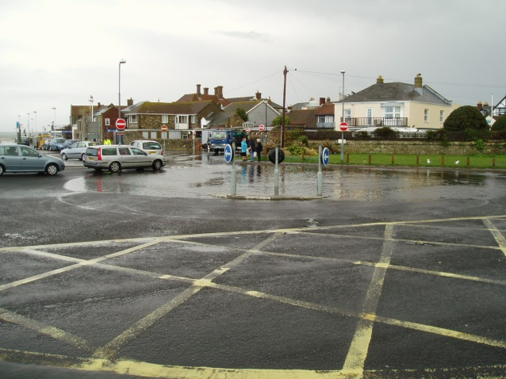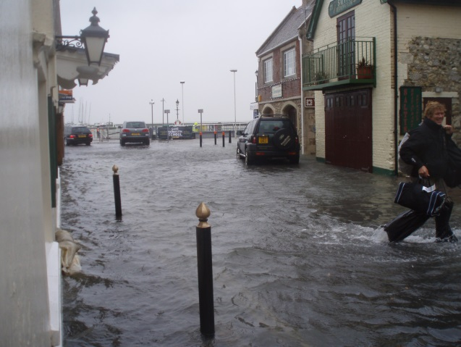
Figure 2. Flooding at Yarmouth 10 March 2008, (a) roundabout near the sea front (source: Isle of Wight Council), (b) looking towards Yarmouth Harbour along Quay Street (Source: Yarmouth Harbour Commissioners)

- Data and methods
As shown in Figure 3, the two main parts of this work are: (1) the participatory visualisation exercise (PVE) which required an animated 3D visualisation of coastal flooding; and (2) the extended event analysis (EEA) assessment of coastal flooding, the latter including simulations of a wider range of events. The PVE in objective (1) was targeted at fulfilling the aims of the community representatives (YCDWG) and funding team (CCATCH) to generate a relatively simple end product that raised greater community awareness of extreme events and SLR. Part 2 was motivated by recent flood events after the 3D visualisation exercise had taken place, and to provide broader results of interest to flood risk management.
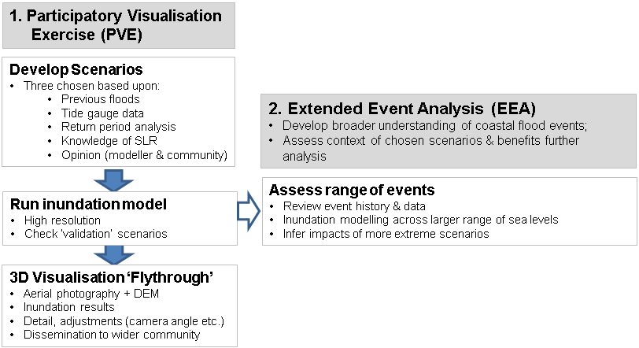
Figure 3. Objectives and method flow chart, showing the process of generating the coastal flood visualisation and model results for the Yarmouth case study

3.1 Generating coastal flood simulations and visualisations
Scenarios for the participatory visualisation exercise (PVE)
There was frequent interaction between representatives from all project participants. This was to verify practical project aspects (e.g. budget and time) and to ensure the outputs were as expected. Initial model runs and sample visualisations of normal high tides and an observed event were crucial to validate the models predictions of flooding, before proceeding to more time-consuming later stages of the study. Production of the visualisations has five key stages:
- Assembling data: the process firstly required data and tools to run hydraulic flood simulations;
- Scenario generation: the YDCWG and associated participants were consulted to deliver results that served their interests within the budget and time available, and decided upon three scenarios (Table 2 and Figure 4). Participatory engagement was important to verify the model outputs and visual aspects of the simulations (as discussed further below). The scenarios selected for the visualisations were to represent (1) normal present-day tides, (2) a present day extreme event, and (3) the same extreme event in the future (with sea level rise), assuming no change to coastal defences.
- Running an inundation model: a method was applied that accounted for the case study’s storm-tide characteristics and incorporated mass conservancy and hydraulic connectivity in the flood event simulations. Initially, to test and build confidence in the model, simulations of the 10 March 2008 flood event were shown to residents who had knowledge about previous floods.
- Visualisation: constructed using the scenario and simulation outputs to generate an engaging and easy to interpret ‘flythrough’ for all audiences.
- Dissemination: CCATCH then provided opportunities for the visualisations to be displayed on a large screen to the community and viewed on the project website.
Scenario 1 was designed to show that the modelling and visualisation could replicate the distribution of sea water on the frequently seen rise and fall of a normal spring tide; whilst Scenario 2 represented an extreme present day sea level event. The basis for Scenario 2 was the storm surge and flood of 10 March 2008 (Wadey et al., 2013) which prompted recent interest in coastal flooding in the town. As discussed in Section 4, there is some uncertainty over the exact height of the peak sea level of this event, hence two ‘sub’ scenarios were provided. Of Scenario 2a and 2b, the YCDWG believed that the former reflected the sea level of 10 March 2008. Scenario 2b was put forward because the YCDWG feared that the same surge could occur on an even larger tide.
Scenario 3 stems from the YCDWG awareness that sea level has been rising over the past century and of scientific studies about future SLR, e.g. the Intergovernmental Panel on Climate Change 5th Assessment Report (IPCC, 2013). The time-scale of interest for this project, from discussion with the YCDWG, is approximately the next 30 years to 2050. The YDCWG and local residents in Yarmouth decided upon a 0.3 m SLR scenario combined with the larger of the two ‘present day’ extreme sea level scenarios that had been defined (Scenario 2b). There is significant uncertainty about future SLR (e.g. due to future emissions scenarios and response of the polar ice sheets). Furthermore, engineers and scientists often prefer to analyse future events via numerical hydrodynamic models and/or principles of extreme value theory (e.g. to consider details such as non-linear tide-surge interaction). For example the UK coast has a comprehensive and recent joint probability analysis of tides and skew surges (McMillan et al, 2011) which suggests for the baseline year of 2008 that Scenario 2a and Scenario 2b are 1 in 20 and 1 in 65 year events, respectively (Figure 4). To the YDCWG these represented the 0.1 m difference between mean high water springs (MHWS) and highest astronomical tide (HAT) (refer to Table 2 and Figure 4). The key issue is that the stakeholder needed to feel ownership of the process and results. Hence the scenarios chosen are reasonable when fitted into context with joint probability analysis and current knowledge of sea level rise. They are discussed further in terms of a wider range of possible floods (Section 4 and Section 5).
Table 2. Still water levels and flood scenario levels. The datums referred to are ‘mCD’ (metres above chart datum), whereas ‘mODN’ is metres above Ordnance Datum Newlyn (approx. mean sea level). Throughout the remainder of the paper values are given in ODN in some instances converting information given by the Yarmouth Harbour Commissioners by using the conversion of -1.98m to convert from CD.
 |  |  | Sea level
Scenario |  | Description | mCD | mODN
Present day astronomical tides | Mean low water springs | MLWS | 0.80 | -1.18
 | Mean low water neaps | MLWN | 1.60 | -0.38
 | Mean sea level | MSL | 2.20 | 0.22
 | Scenario 1 | MHWS | 3.00 | 1.02
 | Highest astronomical tide | HAT | 3.10 | 1.12
Present day storm surges & high tides | Scenario 2a | MHWS + 1.1m storm surge | 4.10 | 2.12
 | Scenario 2b | HAT + 1.1m storm surge | 4.20 | 2.22
SLR scenario & extreme event | Scenario 3 | HAT + 1.1m storm surge + 0.3m SLR | 4.50 | 2.52

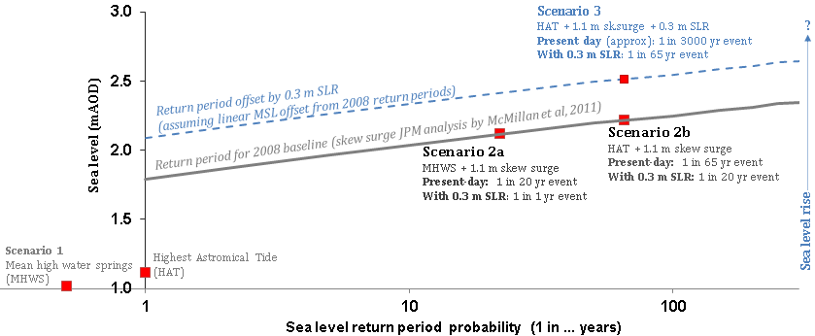
Figure 4: The chosen scenarios selected for visualisations with reference to still water level event return periods at Yarmouth. The simple addition of the largest observed skew surge and astronomical tide is here brought within the range of extreme values available from the return period analysis around the UK coast derived from the skew surge joint probability method by (McMillan et al., 2011; also see Batstone et al., 2013 and Table 1).
Inundation simulation and visualisation
Numerical simulations of inundation are preferable to the ‘bathtub’ method of laying a static planar water level across land heights, since the duration of a storm-tide and resulting flow over the floodplain boundaries, as well as hydraulic connectivity and mass conservancy are considered (Bates et al., 2005). The model deployed to calculate the spread of water on the floodplain during simulated flood events was LISFLOOD-FP (Bates and De Roo, 2000), in this case an inertial formulation of the shallow water equations (Bates et al., 2010). Floodplain flows are treated using a ‘storage cell’ approach and implemented for a raster grid to allow an approximation to a 2D movement of the flood wave. A continuity equation is solved linking flow into a cell and its change in volume, and a momentum equation for each direction where flow between cells is calculated. With good quality topographic data storage cell models can produce similar results to full 2D formulations of the shallow water equations (for sub-critical gradually varied flows only).
Floodplain heights were represented by a Light Detection and Ranging (LiDAR) surveyed digital terrain model (DTM). The DTM format of the LIDAR survey has had many of the surface artefacts (captured by the laser returns) removed and is more suited to flood modelling than the raw digital surface model (DSM) version of the data. The DTM was generated prior to this study by ‘cleaning’ (both via computational algorithms and manual editing) of the raw DSM data set to mask out items which may bias flood modelling, (e.g. cars, houses, vegetation, trees, hedges, etc.) (Figure 5c). This is because the DSM LIDAR survey data set captures the canopy of trees, rather than the tree trunk; or the main body of a car, rather than the wheels, thereby giving a false representation of the study area surface and consequently the 2D floodplain flows. However, objects relevant to the 2D simulation of flood flows (such as buildings) were re-inserted after being manually digitised (the edges of buildings and defences can be missed or unrealistically rounded in the original laser returns). The LiDAR data was collected by the Environment Agency in 2008 at 1 m spatial resolution; this resolution was retained for accuracy of simulation and viewing quality in the visualisation. The resolution and accuracy of LiDAR surveys provide a high quality topographic data set for flood modelling with a vertical root mean square error often within ± 0.3 m (of the ground being measured). The EA aim for at least ± 0.15 m, with survey reports suggesting the LiDAR data collected in the Solent is within ± 0.10 m of the available ground-based check-points. Defence heights were surveyed and provided by the CCO and EA, derived from real-time kinematic (RTK) GPS, with a vertical accuracy of ±0.03 m. Inflow points for LISFLOOD-FP flood simulations were placed manually in each 1 m cell at the edge of the DEM, and each point is associated with a still water level time series.
Following the first ‘stakeholder meeting’ the request was for a single ‘flythrough’ of flooding, with sea level increasing through all scenarios (rather than separate flythroughs each representing separate flooding scenarios). The software used to develop the flythrough from the output flood simulation girds was Fledermaus (http://www.qps.nl/display/fledermaus/main), a powerful interactive 3D data visualization system that is used for a variety of applications and visualisation of remotely sensed and other geo‐spatial data by commercial, academic and government clients. Fledermaus can incorporate a wide variety of data formats for direct import of data to the 3D scene: object types such as digital terrain maps, point clouds, lines, polygons, satellite imagery, etc. can all be loaded and analysed in a single scene. The ascii grid outputs from LISFLOOD-FP simulations were easily displayed in the software; whilst the aerial photography was draped over the digital terrain model to provide a 3D ground model. To retain realisms and visual quality, additional work included ensuring that coastal features (which were not essential to the simulations themselves) such as jetties, piers, etc. were included. Participants met twice throughout the project to agree finer details such as camera angles and sea colour in the visualisation.
Adjusting the model for the extended event analysis (EEA)
Recent floods in 2013/14, most especially on 14 February 2014, raised further concern about coastal flooding in Yarmouth, including more extreme scenarios than those considered in the PVE analysis. Hence, the second objective, the EEA, was to assess flooding across a wider range of inundation possibilities. To do this, the DTM was coarsened to 10 m resolution (using the bilinear interpolation method in ArcGIS so that the model would run more rapidly: this was acceptable since the flood extents of Scenarios 1-3 predicted by the 1 m vs. 10 m versions, matched very closely. Also, for this purpose less emphasis was required upon the visual aspects of the results (which was afforded by the 1 m detailed model which had buildings inserted onto the DEM as cubes). The same defence survey data set was appended to the 10 m DEM. Simulations were run across a single tidal cycle, at 0.1 m increments for each peak sea level scenario, and covered from normal tides to 3.0 mODN (i.e. almost half a metre more than Scenario 3). The sea level time series of the 10 March 2008 storm tide (as recorded at nearby Lymington and verified as similar to storm-tides at Yarmouth) was applied, and simply shifted according to the vertical increase of each simulation’s peak sea level scenario. The buildings from aerial photos and an Ordnance Survey land use map were extracted as point vectors. These were counted as separate buildings according to dividing walls and gardens and a reasonable approximation to an address/property data set. Peak flood depths resulting from each simulation were assigned to each building to generate the results shown in Figure 8.

- Results
Participatory flood visualisation exercise: outcomes of scenarios 1, 2 and 3
Initially some practical uncertainties arose concerning validation and credibility with stakeholders. This concerned (1) the sampling of narrow linear features, and (2) the processed DTM (version of the DEM) product. The first of these issues comprised a gap in the DEM at an embankment (Figure 5a and 5b). Although this is not an area with a large amount of property, this was within the spatial remit of the study and clearly visible in the flythrough (hence important to plausibility of the more extreme scenario modelling). In the Scenario 1 simulations (normal tides), water passed through the embankment and flooded the reedbed area behind the embankment and the River Yar. Local knowledge (from the YCDWG) and a site visit confirmed that the embankment was actually continuous; and the DEM was manually corrected for future flooding predictions. Secondly, at a grassed area south of the town centre (Figures 5c and 5d) the YCDWG suggested that was some overestimation of flood depth (<10 cm). However, following discussion of the uncertainty in the topographic data and scenarios, they accepted the results of Scenario 2a as a primarily accurate replication of the inundation extent and depth of the 10 March 2008 event.
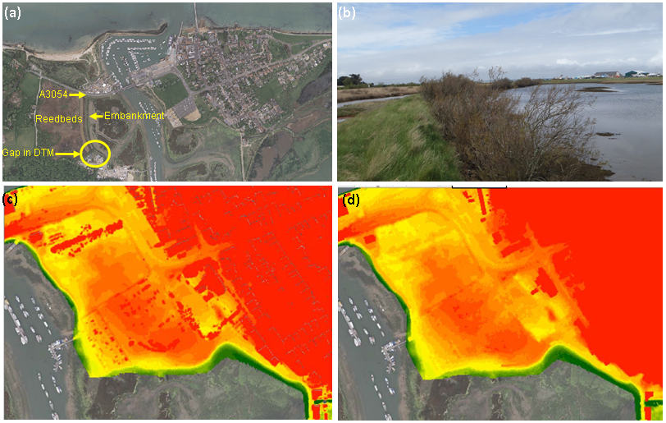
Figure 5. Uncertainties in defence and ground model data; (a) and (b) the area with a gap in knowledge of defences which can cause a significant uncertainty; (c) the DSM and (d) DTM versions of the DEM. As well as removal of houses etc. in the DTM, there are several cm differences in elevation of the grassed area between the data sets.
Initially it was requested that one flythrough be produced demonstrating the water rising through all of the specified scenarios whilst the camera panned around. During the course of the project, the three water level scenarios were also produced as separate static water level flythroughs, using the same camera angle in each film. The stakeholders preferred the static water level films. The initial request for a voice over was amended for a preference that the scenarios were presented as text at the bottom of each film so that the viewer knew which scenario was being shown. The flood visualisation film was promoted by CCATCH and feedback was positive. This included (1) displaying the film to Yarmouth primary school children (aged 7 to 9) as part of an educational programme designed by the CCATCH project, and (2) a Yarmouth ‘drop-in’ day on 19 June 2013, where over 80 people attended, with the film played on a continuous loop. The films were uploaded onto the project website as YouTube movies (http://www.youtube.com/SolentForum) and a web link sent to the Yarmouth community.
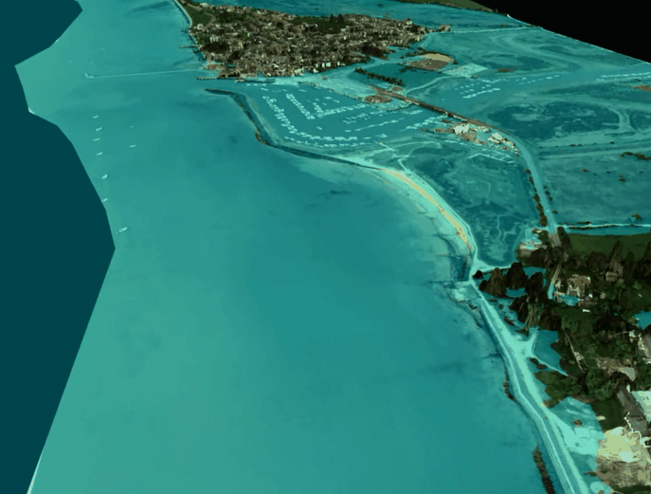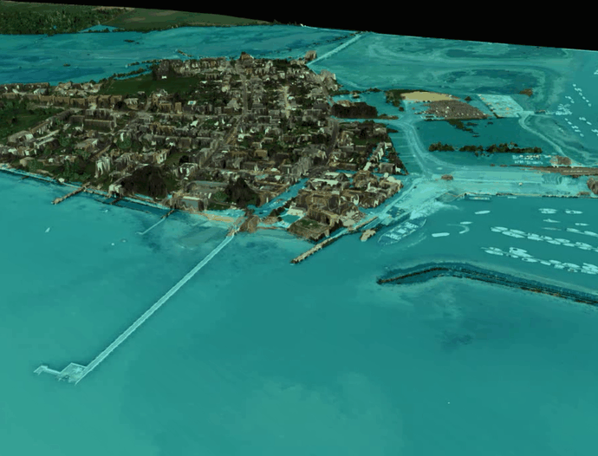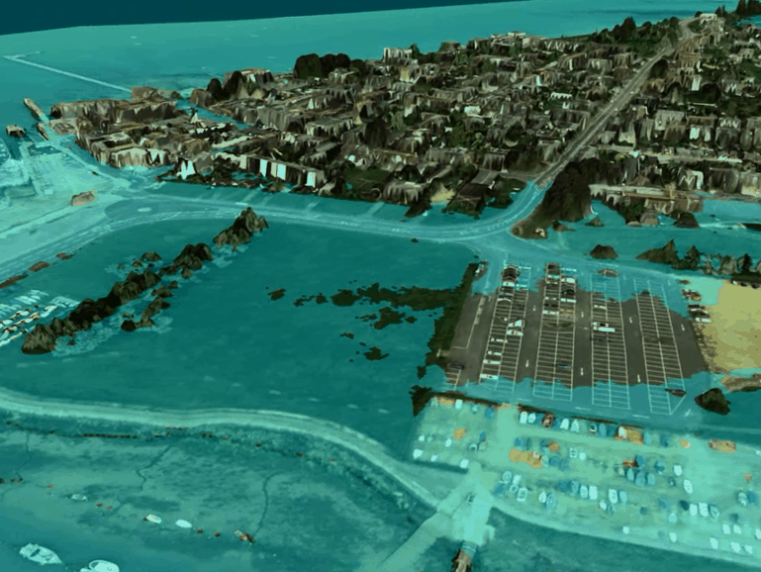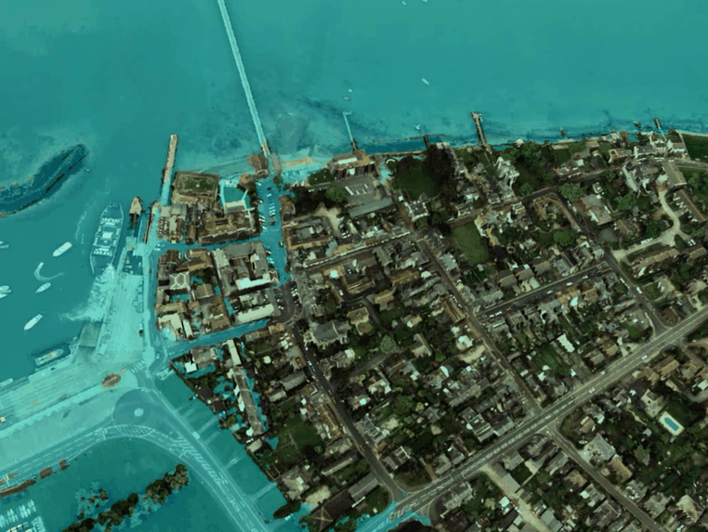
Figure 6. Examples of the visualisation (Scenario 3).
In terms of the implications of the given SLR scenario (‘Scenario 3’) for actual flooding, the relatively simple floodplain topography and inflow routes around Yarmouth town centre meant that the most obvious effect is to simply increase the predicted flood depth by 0.3 m (i.e. the elevation of the SLR scenario) (Figure 6). However, there is a 100 m by 70 m area of newly-inundated land north of the town centre, with flooding able to connect with the open coast, which is a significant change to the flooding previously experienced by the Yarmouth community.
The simulation implies changes to flood events with SLR, although some of these changes require further interpretation beyond what can be seen in the simulation (albeit prompted by the data that the simulation provides). The main impacts of the 0.3 m SLR upon an (already extreme) flood event at Yarmouth, and assuming defences remain unchanged, are that:
- Buildings already surrounded by sea water in the event of a present-day extreme storm-tide, are more likely to experience flooded interiors;
- Roads around the town centre would be increasingly impassable (i.e. 0.3 m of flowing water is considered capable of moving an average car);
- Thorley Brook is more likely to be filled, and surround the back of the town with deep water (several gardens back onto this watercourse).
- Flooding is more hazardous in the areas previously affected, with water depths between 0.5 – 1 m across much of the flooded area around the north of the town centre;
- The onset of flooding may be faster, whilst the duration will be more prolonged.

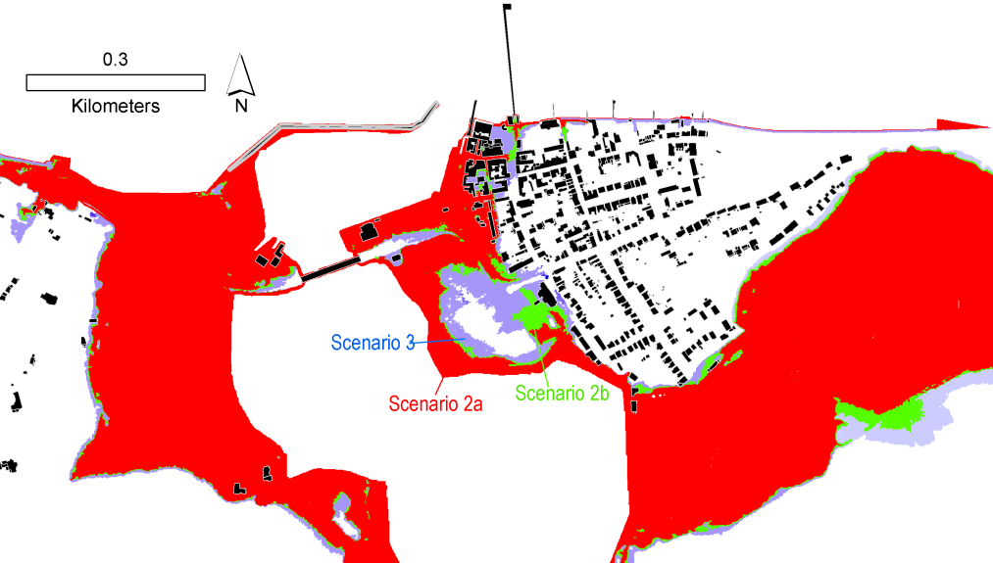
(a)
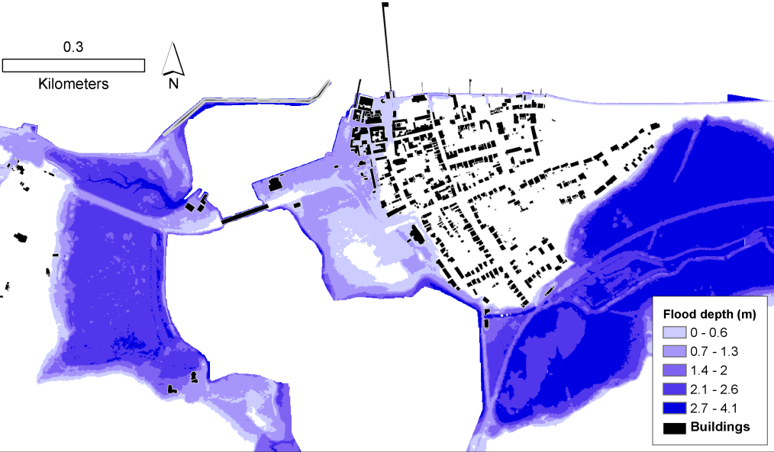
(b)
Figure 7 (a) the different flood extents from the scenarios selected for visualisation; (b) the water depth distribution from Scenario 3.
A wider range of sea level event and inundation possibilities is discussed in the following section; and their relevance to present day and future coastal floods, and the concepts surrounding the scenarios set out by the CCATCH and YCDWG interaction described earlier in this paper.
Extended event analysis (EEA) for Yarmouth
Since the participatory scenarios and visualisation, Yarmouth was affected by a series of floods which suggested an extended analysis would augment the PVE. In late 2013 to early 2014 the UK experienced a period of unusually relentless storms and flooding (MetOffice, 2014) during which Yarmouth can be defined as coastally ‘flooded’ on at least three occasions (Table 1). The first coastal flood of these events was on 27-28 October 2013 when during 99 mph [159 km/hr] gusts of wind (recorded 7 km from Yarmouth at ‘The Needles’). This is unusual as it was a neap tide when floods are not expected. Sea level time series recorded at the Yarmouth tide gauge, compared to the predicted tide, suggests a 1.4 m NTR at high water, which is larger than any previous events in the Solent. The flood was shorter lived that most surge events, and hence requires further analysis to determine if this was, technically, due to seiching (rather than due to a storm surge alone). Further to this, on 14 February 2014 an intense windstorm generated an exceptional sea level at Yarmouth, which exceeded Scenario 2a and almost matched Scenario 2b. This was accompanied by a 1.25 m skew surge, as such casting doubt over previous assertions that 1.1 m is the upper surge limit at this location.
However, the comparison between observed sea levels of 10 March 2008 and 14 February 2014 is not exact, because the tide gauge was not operational during the former of these events. On 10 March 2008, the ‘observed’ height of 2.12 mODN is taken from the harbour master’s observation of high water relative to the Harbour Wall (a benchmark of 1.92 mODN) and then subtracting the predicted tide. The 14 February 2014 high tide of 2.17 mODN was recorded by a levelled digital gauge; and is the highest sea level known at Yarmouth. However, the event occurred at night, which hinders an exact inundation comparison with previous events and almost no photographs exist. Eyewitness accounts suggest that the 14 February 2014 event was "slightly worse" than 10 March 2008 which corresponds with observations at nearby Lymington where the sea level was also more extreme. Other factors to consider when comparing events for which a tide gauge is absent, is that local wind and waves may also confuse visual observations of sea level, whilst the tide table readings (referred to for estimation of the surge) are to one decimal place. What is notable is that despite the more severe conditions of the 14 February event, improved preparation (e.g. flood warnings, sandbags) since 10 March 2008 meant that less property was detrimentally affected.
The events observed since the PVE challenged the validity of the selected scenarios. This was largely because a focal point in the Yarmouth community had been the surge of 10 March 2008 (estimated 1.1 m) and the fear that this could hypothetically occur on higher astronomical tides and mean sea level. Coastal engineers and scientists usually consider this notion within the context of joint probability analysis, inclusive of tide-surge interaction (Horsburgh and Wilson, 2007). However, if the 1.3 m skew surge of 14 February 2014 occurred on the 10 March 2008 tide, a sea level of 4.3 mCD (2.3 mODN) would result. This is equivalent to almost a 1 in 200 year return period sea level event (with reference to the year 2008) and exceeds ‘Scenario 2b’ by 0.1 m. Also, in principle this suggests that the SLR depiction given by ‘Scenario 3’ could be extended. Therefore to determine sea level events with substantial impact on buildings within the floodplain, and the sensitivity of coastal flood consequence predictions to sea level variations; the inundation modelling is continued across a wider range of sea levels (at 0.1 m sea level increments, for a total of 21 simulations). The flood outlines are used to count the number of buildings affected by inundation (Figure 8).
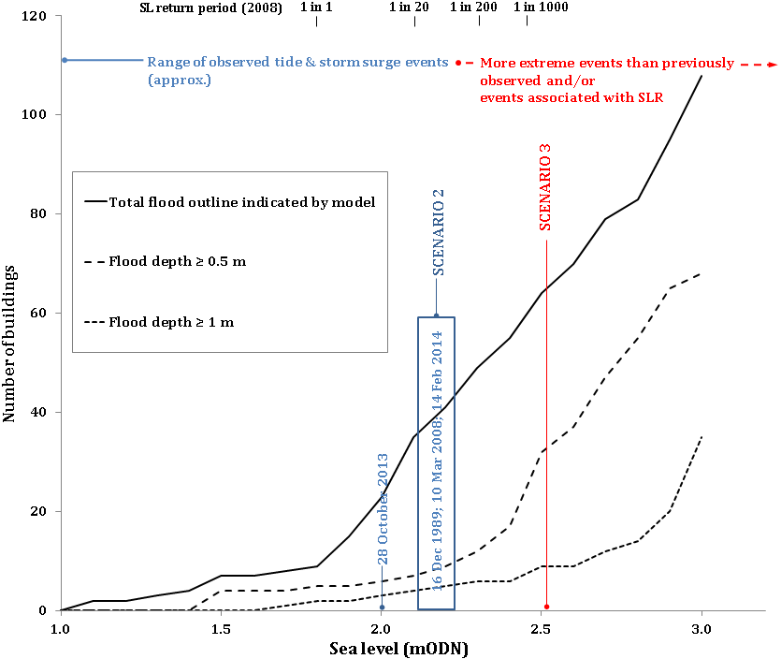
Figure 8. Counts of buildings predicted to be flooded by a single tidal cycle of inundation simulation, at 0.1 m increments of sea level, using LISFLOOD-FP, 10 m resolution DEM, and a homogenous friction value of n=0.035 (see Wadey et al, 2012).
Figure 8 was generated to be complimentary to the limited number of scenarios of the PVE; and shows a range of inundation possibilities at 0.1 m increments of sea level. Shown on the y-axis is the number of buildings in Yarmouth that fall within (a) the total flood outline, and cells with depths greater than (b) 0.5 m and (c) 1 m. These depth ‘thresholds’ s are a rough indicator of areas where property is likely to be subject to damages or face greater challenges when protecting against deeper flood waters (Penning-Rowsell et al., 2005; Wadey et al., 2013). Scenario 2 and the ‘present-day’ floods are grouped (i.e. the exact sea level height associated with these events is not known, but approximately falls within this span). Notably, beyond the floods observed in the present day, the count of buildings within cells exceeding 0.5 m water depth (i.e. more indicative of detrimental impacts to property) increases sharply. The model outputs which correspond with ‘Scenario 3’ suggest that 0.3 m SLR allows the total number of buildings exposed to coastal flood water during an extreme event (as averaged between Scenarios 2a and 2b) to increase from 38 to 65. However, perhaps more significant is that the count for the number buildings in areas flooded to depths of ≥ 0.5 m increases from 8 to 33, suggesting greater interior damages. Increasing the SLR scenario to the maximum of the simulation range (3m ODN, i.e. almost 0.8 m SLR upon Scenario 2b) causes the number of buildings in the ≥ 0.5 m flood depth outline to increase to almost 70. This is discussed in the following section. Hence, Figure 8 provides a powerful summary of the consequences of future flooding which informed stakeholders can use to discuss and quantify these issues.
- Discussion
Lessons gained from objective 1 (PVE)
Visualising and disseminating coastal flood modelling outputs engaged a range of participants in the Yarmouth coastal community. This was both via the discussion of scenarios with a local ‘coastal working group’, and the capability that the visualisation provided for a larger amount of the community to understand the extent of observed and hypothetical coastal flood events.
From a project perspective, the main cost was in the model set-up and construction of visualisations, whereas flood simulations could easily be re-run. The time-consuming rendering of the 3D flythrough animation meant that early participatory interaction (in this case using lower-quality trial visualisations and validation flood simulations) was important. For example the base scenario of MHWS and replicating the 10 March 2008 event ‘set the scene’ and made the film look credible. It was important for the respective participants to regularly interact for both the scenario generation and decisions upon finer detail (e.g. colour, camera angle etc.). The inclusion of the PVE within the CCATCH project benefited from (1) freely available data (aerial photography, LiDAR data and defence heights) from the South-east Regional Coastal Monitoring Programme www.channelcoast.org and the Environment Agency; (2) access to an existing research case study (Wadey et al., 2012); and (3) availability of an established 2D inundation model (LISFLOOD-FP). Also linked to the CCO contribution was the availability of software capable of integrating and manipulating model inputs and outputs (ArcGIS, Fledermaus). Local knowledge and the data set of extreme water level probabilities were invaluable for the scenario development and analyses. However, even with these considerable resources and the small size of the case study, some uncertainties remain in flood predictions associated with extreme sea level scenarios. Firstly, the LiDAR is a pre-‘cleaned’ DTM product, a useful concept in principle although the process of removing surface artefacts can introduce systematic errors as highlighted by Liu (2008). A more transparent understanding of these processing routines is needed. In this case study, detailed examination of the data and local knowledge of the validation flood event, established that too much height may have been masked from the surface in one area (Figure 5). However, clarification of this to the YCDWG stakeholders maintained their confidence in further simulations. Secondly, flood predictions from boundary inflows were sensitive to discontinuities in flood defence lines or crest level errors, and additional surveying and local knowledge are required. Thirdly, the lack of consistent historical tide gauge readings adds uncertainty over previous observations and hence in the model simulations. This adds further justification for the EEA which is now described.
Implications of objective 2 (EEA)
The EEA is largely summarised by Figure 8, and compliments the PVE. This is because the prescription of boundary conditions for coastal flood event simulations, and fitting these within relevant scenarios, was one of the more complex issues encountered. This was further complicated by historical discontinuities in the hard data (e.g. in this case lack of a tide gauge to verify the still water level during the 16 December 1989 and 10 March 2008 events, table 1).
The outcomes of recent observed events (table 1) and the EEA (figure 8), suggests that even with some uncertainty, the floodplain water levels and consequences of present-day coastal floods are manageable given appropriate warning. This is inferred from the lack of gradient increase in the count of buildings affected. However, at sea levels beyond what is likely at current MSL, the number of buildings threatened by deeper sea water rises distinctly. The EEA and Figure 8 suggest that the YCDWG’s requested ‘Scenario 3’, is a reasonable starting point for a participatory visualisation exercise. By representing 0.3 m SLR by 2050 (considered relevant to their interests for its degree of realism in context with available knowledge) a large change to flood impacts is discernable in the ≥ 0.5 m impact line (figure 8). However, this format of figure is beneficial to viewing scenarios pragmatically, for example merging larger present-day events than were considered in the PVE and/or combining different levels of SLR. The IPCC 5th Assessment Report suggests that if drastic emissions cuts are achieved from 2020 onward (Scenario RCP2.6), sea levels will rise by between 0.26 and 0.54 m (on 1986-2005 levels) by the end of the century (IPCC, 2013). Most previous reports concur that a rise in the order of approximately 0.5 m is likely over the next century. Much larger changes are theoretically possible, for example as indicated by palaeo-climatological sea level records (e.g. Rohling et al., 2013) and the United Kingdom Climate Impacts Programme (Lowe et al., 2009) has released estimates (based upon earlier IPCC work) of the likely changes around the UK coast, which are in general agreement with the IPCC, but with regional variations based on vertical land movement, and provision of a ‘High ++’ scenario of 1.9 m SLR (see also Nicholls et al., 2014).
The maximum sea level covered by the simulations in Figure 8 is equivalent to 0.8 m SLR upon Scenario 2b and 0.5 m additional SLR upon the YCDWG’s Scenario 3. Compared to the extent of buildings threatened by the flood waters during present day extreme sea level events, this additional SLR inundates (approximately) 70 additional buildings. Relevant to coastal management decisions over the coming decades is the number of buildings exposed to greater depths: those exposed to half a metre depth of flood water increases tenfold (compared to the present day), and 35 buildings would be surrounded by more than 1 m deep water. In such a situation, flooding is more hazardous and temporary and emergency mitigation measures (e.g. sandbags) less effective.
Further work
In future inundation studies at Yarmouth of elsewhere, other flood sources and pathways would ideally be included. Wave overtopping was not included as a boundary input, due to the high uncertainties involved e.g. (Pullen et al., 2009) especially when coupled to inundation simulations (Smith et al., 2012). Furthermore Yarmouth has not experienced a major coastal flood in recent years attributed mainly to wave overtopping, and there is a lack of data to calibrate overtopping predictions, which could also have complicated the participatory component of the work. Properties on the open coast would be exposed to higher overtopping rates with SLR, whilst wind waves in the harbour would also worsen inundation. This could more effectively be factored into future EEA type assessments (c.f. Wadey et al, 2012) than for the PVE; because the inherent uncertainty could be more easily highlighted. A more event- and site-specific understanding of the storm-tide water level time series would be appropriate to accurately simulate the volume that can flow into the floodplain for different events (i.e. here the 10 March 2008 Lymington sea level time series was used and shifted according to the scenario sea level). Further higher resolution hydrodynamic modelling of surges in the region, calibrated with the recent observational data, would be insightful (c.f. Quinn et al, 2012).
The ultimate goal is that the information from such visualisations can be converted into well informed and useful coastal management actions, i.e. which mitigate flooding with suitable cost and environmental consequences. For example Jude et al. (2006, 2013) describe integrated GIS methodologies to allow virtual reality representations of a current site environment and simulations of what occurs after intervention. This is especially relevant if larger structural measures are ever put into place for Yarmouth’s flood defence; and would certainly be relevant to undertaking a broader scale coastal visualisation project for the Solent as a whole. For Yarmouth, the CCATCH work (of which the PVE was a part of) did conclude with an ‘Adaptation Plan’ (HCC, 2014) which is described in more detail in the following section. This suggests that further work to repeat Figure 8 with both sea-level rise scenarios and the adaptation measures in place would be useful to better understand the benefits of the Adaptation Plan and issues around timing of implementation.

- Conclusions
This paper demonstrates detailed coastal flood simulations of Yarmouth, Isle of Wight, including the effects of sea level rise. The first part of this work, a participatory visualisation exercise contributed to awareness of sea level rise and its impacts to the coastal community. Community reactions to the dissemination of this flood ‘flythrough’ ranged from this providing new knowledge, and in other cases ‘official' confirmation of previous knowledge’ (HCC, 2014). Such simulations are a powerful technique to promote, educate, identify and prepare for extreme events and SLR. Furthermore, as an element of the wider ‘CCATCH’ project, an ‘Adaptation Plan for Yarmouth’ (HCC, 2014) was produced. Practical elements of the plan to be introduced by 2050 include inserting gates to Bridge and Quay Street (areas previously flooded as a result of extreme sea level events), sluices to prevent ingress of water into drains, raising floor levels in vulnerable town centre properties, and installing larger breakwaters.
The second component of the work, which we refer to as the extended event analysis, included additional computational simulations of inundation and a review of more data than had been accessed during the participatory visualisation. Flooded building counts and impacts were assessed across a larger range of loadings. This was to understand some of the uncertainty in knowledge of current sea level extremes. This was an important response to previous assumptions that were challenged by the large storm surges at Yarmouth, across the unusually clustered period of sea level extremes in the 2013/2014 winter. This is complimentary to the visualisation exercise, and this information has since also been passed onto the Yarmouth Coastal Defence Working Group, who are continuing the legacy of the Yarmouth Adaptation Plan.
It was commented by a member of the community at a public viewing of the flood flythrough film, “that sea level rise is going to be one of the most important aspects of our lives in the future” (HCC, 2014). For the Yarmouth case study, even the smaller estimate of SLR used in this paper suggest that by midway through the 21st century the 10 March 2008 event (and similar floods) could have an annual probability; whilst events with the same probability (of those already seen) will be significantly more severe. Coastal settlements such as Yarmouth are more accustomed to living without the presence of significant risk to life from coastal floods, or large structural defence systems. Various factors affect a coastal communities’ acceptance of existing and changing flood risk from sea level and coastal extremes. Studies such as this, may contribute to a community accepting changes and making management decisions; beneficial to local-scale planning and adaptation to sea-level rise. The local knowledge accessed as part of such a participatory exercise, and scrutiny of results in such as visualisation, can also allow the flood modeller to test ideas against local knowledge and improve the underlying flood model. Other benefits include improved interaction between the scientific and coastal community, and promotion of data sharing between the organisations involved.

Acknowledgements
This study was made possible thanks to data provided by the Environment Agency and Channel Coastal Observatory, and the LISFLOOD-FP inundation model developed by Paul Bates and team at the University of Bristol. CCATCH provided funding and community of Yarmouth gave their time and constructive feedback. Tim Francis and Chris Lisher respectively of the Yarmouth Coastal Defence and Working Group (YCDWG) and Yarmouth Harbour Commissioners also provided local knowledge and data.

- References
Anthoff, D., Nicholls, R. J., Tol, R. S. J. & Vafeidis, A. T. 2006. Global and regional exposure to large rises in sea-level: a sensitivity analysis, Tyndall Centre for Climate Change Research Working Paper 96.
Araújo, I. B. & Pugh, D. T. 2008. Sea Levels at Newlyn 1915–2005: Analysis of Trends for Future Flooding Risks. Journal of Coastal Research, 203-212.
Bates, P. D., Dawson, R. J., Hall, J. W., Horritt, M. S., Nicholls, R. J., Wicks, J. & Mohamed Ahmed Ali Mohamed, H. 2005. Simplified two-dimensional numerical modelling of coastal flooding and example applications. Coastal Engineering, 52, 793-810.
Bates, P. D. & De Roo, A. P. J. 2000. A simple raster-based model for flood inundation simulation. Journal of Hydrology, 236, 54-77.
Bates, P. D., Horritt, M. S. & Fewtrell, T. J. 2010. A simple inertial formulation of the shallow water equations for efficient two-dimensional flood inundation modelling. Journal of Hydrology, 387, 33-45.
Batstone, C., Lawless, M., Tawn, J., Horsburgh, K., Blackman, D., McMillan, A., Worth, D., Laeger, S. & Hunt, T. 2013. A UK best-practice approach for extreme sea-level analysis along complex topographic coastlines. Ocean Engineering.
Baxter, P. J. 2005. The east coast Big Flood, 31 January–1 February 1953: a summary of the human disaster. Philosophical Transactions of the Royal Society A: Mathematical, Physical and Engineering Sciences, 363, 1293-1312.
Billen, M. I., Kreylos, O., Hamann, B., Jadamec, M. A., Kellogg, L. H., Staadt, O. & Sumner, D. Y. 2008. A geoscience perspective on immersive 3D gridded data visualization. Computers & Geosciences, 34, 1056-1072.
Bradbury, A. & Kidd, R. 1998. Hurst spit stabilisation scheme. Design and construction of beach recharge. 33rd MAFF conference of river and coastal engineers 1-3 July 1998. Keele University, UK.
Bütow, H. 1963. Die große Flut in Hamburg. Eine Chronik der Katastrophe vom Februar 1962. Freie und Hansestadt Hamburg, Schulbehörde.
DE. 2014. Dorset storms: Severe flood warning for Christchurch Harbour and chaos on roads and trains - last updated 6:02am Saturday 15th February 2014. Daily Echo.
EA 2010. Solent & South Downs Area Report 10 March tidal flooding event, Hampshire & Isle of Wight. A report of events, consequences and conclusions. Version 2 Jan 2010. Environment Agency.
Entec 2007. Isle of Wight Strategic Flood Risk Assessment for Isle of Wight Council by Entec UK Limited, Doc Reg No. c011.
Evans, E., Office of, S. & Technology 2004. Foresight : scientific summary. Volume II, Managing future risks, London, Office of Science and Technology.
Gallagher, A. & Inder, A. 2012. CCATCH – The Solent Evaluation of the Beaulieu to Calshot Pathfinder Available online: http://ssudl.solent.ac.uk/2376/1/CCATCH_evaluation_report.pdf: Hampshire County Council.
Haigh, I., Butcher, P., Harris, J. M., Cooper, N. J. & Trip, I. 2004. Developing an improved understanding of storm surges in the Solent. 39th DEFRA flood and coastal management conference, June 29 - July 1 2004. York, UK.
Haigh, I., Nicholls, R. & Wells, N. 2009. Mean sea level trends around the English Channel over the 20th century and their wider context. Continental Shelf Research, 29, 2083-2098.
Haigh, I., Nicholls, R. & Wells, N. 2010. Assessing changes in extreme sea levels: Application to the English Channel, 1900–2006. Continental Shelf Research, 30, 1042-1055.
Haigh, I. D., Nicholls, R. J. & Wells, N. C. 2011. Rising sea levels in the English Channel 1900 to 2100. Proceedings of the Inst Civ Eng - Maritime Engineering, 164, 81-92.
Hallegatte, S., Green, C., Nicholls, R. J. & Corfee-Morlot, J. 2013. Future flood losses in major coastal cities. Nature Clim. Change, 3, 802-806.
HCC 2012. CCATCH - the Solent Risk Profiling and Site Selection February 2012. Available at: http://www.environment-agency.gov.uk/static/documents/Utility/HCCProfilingReport.pdf [accessed: February 2014].
Horsburgh, K. J. & Wilson, C. 2007. Tide-surge interaction and its role in the distribution of surge residuals in the North Sea. Journal of Geophysical Research, 112, 1-13.
Hinkel, J., Lincke, D., Vafeidis, A. T., Perrette, M., Nicholls, R. J., Tol, R. S., Marzeion, B., Fettweis, X., Ionescu, C. & Levermann, A. 2014. Coastal flood damage and adaptation costs under 21st century sea-level rise. Proceedings of the National Academy of Sciences, 111, 3292-3297.
IPCC (Intergovernmental Panel on Climate Change). Climate Change 2013: The Physical Science Basis. Contribution of Working Group I to the Fifth Assessment Report of the Intergovernmental Panel on Climate Change (eds Stocker, T. F. et al.) (Cambridge Univ. Press, 2013)
IRF. 2011. Multi-Agency Flood Response Plan - v1.1, March 2011 [Online]. Isle of Wight Resilience Forum - report prepared by Isle of Wight Local Authority Emergency Management. Available: http://www.iwight.com/home/emergency/emergency_planning/images/iwightIRFFloodPlan-v1.1March2011Annex4.pdf [Accessed 11th January 2013.
IWC 2011. Isle of Wight Shoreline Management Plan. Isle of Wight Council. Available online: http://www.coastalwight.gov.uk/smp/contents.htm [accessed February 2014].
IWCP. 2013. St Jude storm — readers' pictures, Tuesday October 29, 2013. Isle of Wight County Press. Online: http://www.iwcp.co.uk/news/news/st-jude-storm-readers-pictures-51473.aspx [accessed January 2014]
Jude, S., Jones, A. P., Andrews, J. & Bateman, I. J. 2006. Visualisation for participatory coastal zone management: a case study of the Norfolk Coast, England. Journal of Coastal Research, 1527-1538.
Jude, S., Mokrech, M., Walkden, M., Thomas, J. & Koukoulas, S. 2013. Visualising potential coastal change: comunicating results using visualisation techniques. In: Nicholls, R. J., Dawson, R. J. & Day, S. A. (eds.) Broad Scale Coastal Simulation New Techniques to Understand and Manage Shorelines in the Third Millennium. Springer.
Lamb, H. 1991. Historic storms of the North Sea, British Isles and Northwest Europe, Cambridge, Cambridge University Press.
Law, C. R. 1975. Storm surges in the English Channel. Hydrogr J, 2, 30-34.
Lichter, M., Vafeidis, A. T., Nicholls, R. J. & Kaiser, G. 2010. Exploring Data-Related Uncertainties in Analyses of Land Area and Population in the “Low-Elevation Coastal Zone” (LECZ). Journal of Coastal Research, 757-768.
Lowe, J. A., Howard, T., Pardaens, A., Tinker, J., Holt, J., Wakelin, S., Glenn, M., Leake, J., Wolf, J., Horsburgh, K., Reeder, T., Jenkins, G., Ridley, J., Dye, S. & Bradley, S. 2009. UK Climate Projections Science Report: Marine and Coastal Projections. Exeter, UK: Met Office Hadley Centre.
McGranahan, G., Balk, D. & Anderson, B. 2007. The rising tide: assessing the risks of climate change and human settlements in low elevation coastal zones. Environment and Urbanization, 19, 17-37.
McMillan, A., Batstone, C., Worth, D., Tawn, J. A., Horsburgh, K. & Lawless, M. 2011. Coastal flood boundary conditions for UK mainland and islands. Project: SC060064/TR2: Design sea levels.: Published by: Environment Agency, Bristol, UK.
McRobie, A., Spencer, T. & Gerritsen, H. 2005. The Big Flood: North Sea storm surge. Philosophical Transactions of the Royal Society A: Mathematical, Physical and Engineering Sciences, 363, 1263-1270.
MetOffice 2014. Winter storms, December 2013 to January 2014. Online report, available at: http://www.metoffice.gov.uk/climate/uk/interesting/2013-decwind [accessed February 2014].
NFDC 2010. North Solent Shoreline Management Plan. Compiled by/lead authorty: New Forest District Council. Available at:http://www.northsolentsmp.co.uk.
Nicholson-Cole, S. A. 2005. Representing climate change futures: a critique on the use of images for visual communication. Computers, environment and urban systems, 29, 255-273.
Nicholls R. J., Hanson S.E., Lowe J.A., Warrick R.A., Lu X, Long A.J.. Sea‐level scenarios for evaluating coastal impacts. WIREs Clim Change 2014, 5: 129-150. doi: 10.1002/wcc.253
NRA 1990. Lymington/Pennington flood investigation – interim report. Environment Agency report reference number: IMP/SCH/008/5054. Report produced for National Rivers Authority Southern Region by Southern Projects Ltd.
Penning-Rowsell, E., Johnson, C., Tunstall, S., Tapsell, S., Morris, J., Chatterton, J., Green, C., Wilson, T., Koussela, K. & Fernandez-Bilbao, A. 2005. The benefits of flood and coastal risk management: a manual of assessment techniques, Middlesex University Press: London.
Pugh, D. T. 1987. Tides, surges and mean sea-level. A handbook for engineers and scientists, Wiley, Chichester.
Pullen, T., Allsop, W., Bruce, T. & Pearson, J. 2009. Field and laboratory measurements of mean overtopping discharges and spatial distributions at vertical seawalls. Coastal Engineering, 56, 121-140.
Quinn, N., Atkinson, P. & Wells, N. C. 2012. Modelling of Tide and Surge Elevations in the Solent and Surrounding Waters: The Importance of Tide-Surge Interactions. Estuarine, Coastal and Shelf Science, 112, 162-172.
Rohling, E. J., Haigh, I. D., Foster, G. L., Roberts, A. P. & Grant, K. M. 2013. A geological perspective on potential future sea-level rise. Scientific reports, 3.
Ruocco, A. 2009. Reconstructing coastal flood occurrence in the Solent since 1935 using historical data. MSc Integrated Environmental Studies MSc, University of Southampton.
Ruocco, A., Nicholls, R., Haigh, I. & Wadey, M. 2011. Reconstructing coastal flood occurrence combining sea level and media sources: a case study of the Solent, UK since 1935. Natural Hazards, 59, 1773-1796.
SDE. 2014. Hampshire flood chaos 'becomes a risk to life' - last updated 11:49pm Friday 14th February 2014. Southern Daily Echo.
Sheppard, S. R. J. 2005. Landscape visualisation and climate change: the potential for influencing perceptions and behaviour. Environmental Science & Policy, 8, 637-654.
Sheppard, S.R.J., 2012. Visualizing Climate Change: A Guide to Visual Communication of Climate Change and Developing Local Solutions, Routledge, London, 514pp.
Solent Forum. 2013. Coastal Communities Adapting to Change (CCATCH) - The Solent [Online]. Available: http://www.solentforum.org/current/CCATCH/.
Smith, R. A. E., Bates, P. D. & Hayes, C. 2012. Evaluation of a coastal flood inundation model using hard and soft data. Environmental Modelling & Software, 30, 35-46.
Steers, J. A. 1953. The East Coast Floods, January 31 - February 1 1953. Geographical Journal, 119, 280-295.
Wadey, M., Nicholls, R. & Haigh, I. 2013. Understanding a coastal flood event: the 10th March 2008 storm surge event in the Solent, UK. Natural Hazards, 1-26.
Wadey, M. P., Nicholls, R. J. & Hutton, C. 2012. Coastal Flooding in the Solent: An Integrated Analysis of Defences and Inundation. Water, 4, 430-459.
West, I. M. 2010. Hurst Spit, Barrier Beach of the West Solent, Hampshire: geology of the Wessex Coast [Online]. Available: http://www.soton.ac.uk/*imw/Hurst-Castle-Spit.htm#Hurst-Spit-Erosion-History [Accessed 27 June 2010.
YCDWG 2010. Adapting to coastal flooding in the Yamourth area in the 21st century - a report by Yarmouth Coastal Defence Working Group, December 2010.
YCDWG. 2014. RE: Coastal flood events in Yarmouth during 2013-2014: observations from local residents & harbour master at Yarmouth, Isle of Wight (represented as Yarmouth Coastal Defence Working Group, YCDWG).

